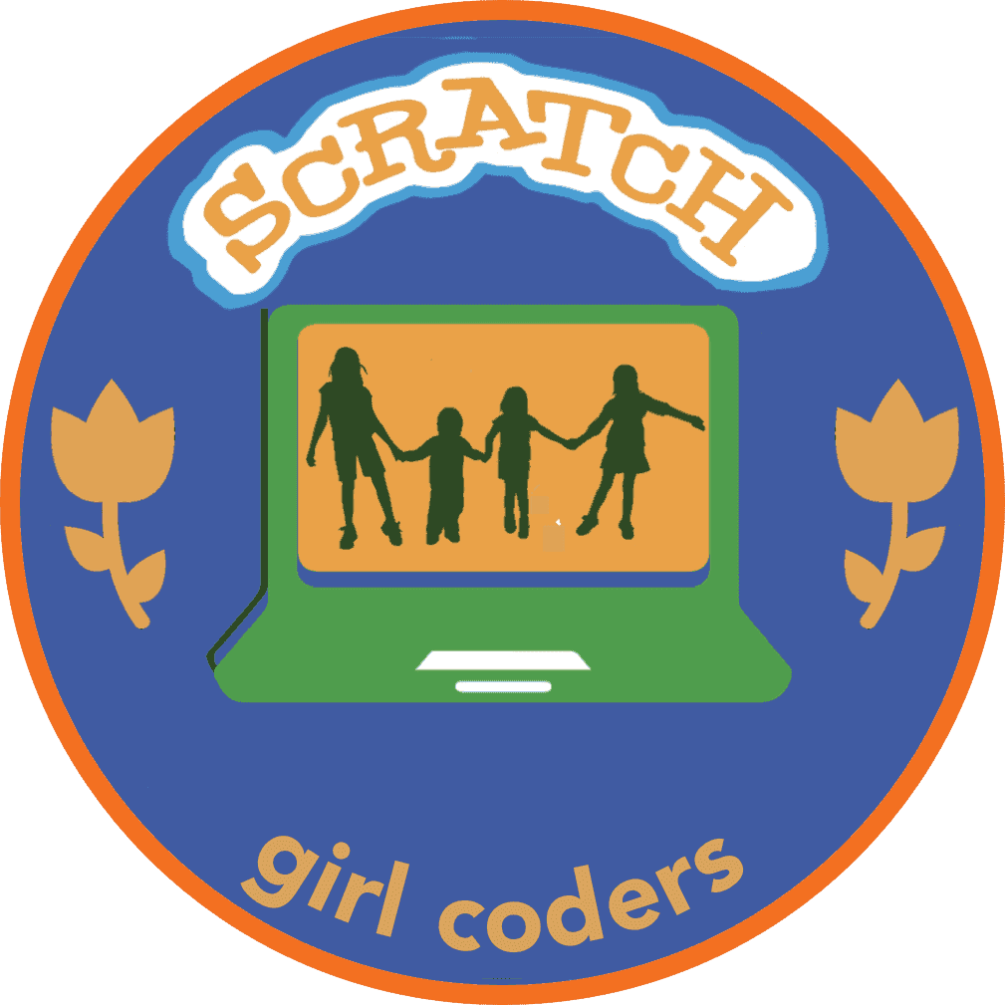

SCRATCH

PATCH

WORKSHOP

Hi Girls,
- Are you fascinated with coding, or maybe just curious to try?
- Want to learn to create interactive stories, games and animations?
- Join this free Scratch patch workshop!
- No coding experience needed.
- Walk home with your own applications and a Scratch fun patch.

LET THE FUN BEGIN!

May 19th, 2018, 9am to 11pm
San Jose Public Library, San Jose, CA 95112

Who: Grade 2 to 8
Spots: 25
Registration: https://www.eventbrite.com/e/scratchpatch
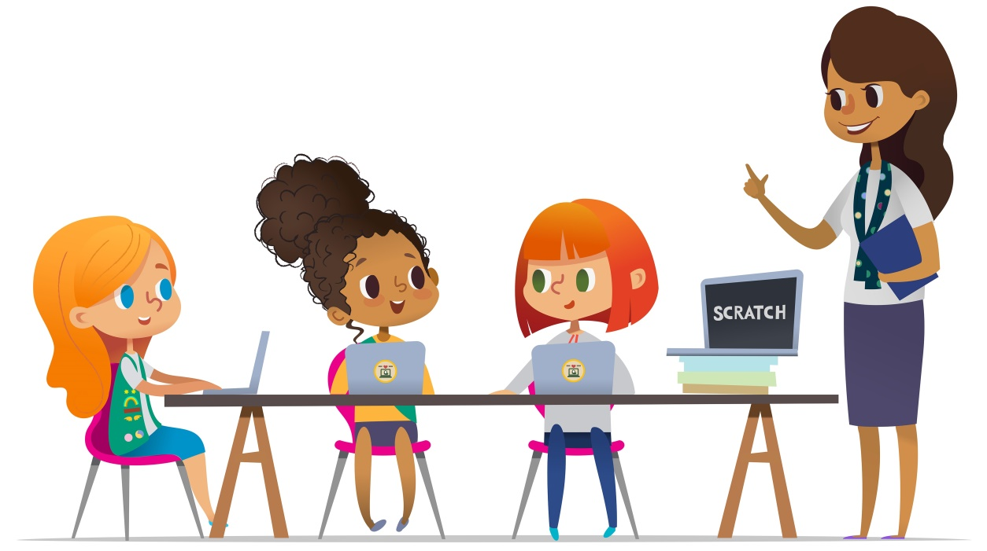
Questions: Contact us at info@girlcoders.net

Inspire
Girls to Explore
Computer Science

