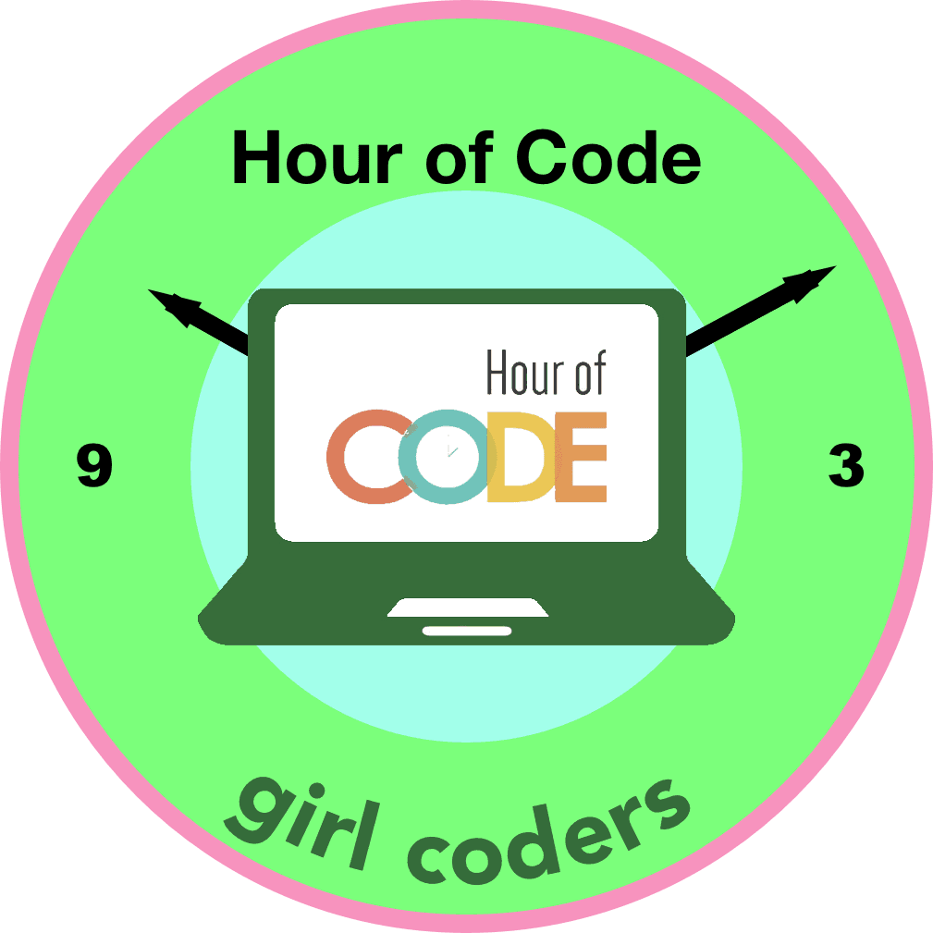

Hour of Code

PATCH

WORKSHOP

Hi Girls,
- Are you fascinated with coding, or maybe just curious to try?
- Want to learn to create interactive stories, games and animations?
- Join this free Hour of Code patch workshop!
- No coding experience needed.
- Walk home with your own applications and an Hour of Code fun patch.

LET THE FUN BEGIN!

May 19th, 2018, 9am to 11am
San Jose Public Library, San Jose, CA 95112

Who: All Grades
Spots: 25
Registration: https://www.eventbrite.com/e/hourofcodepatch
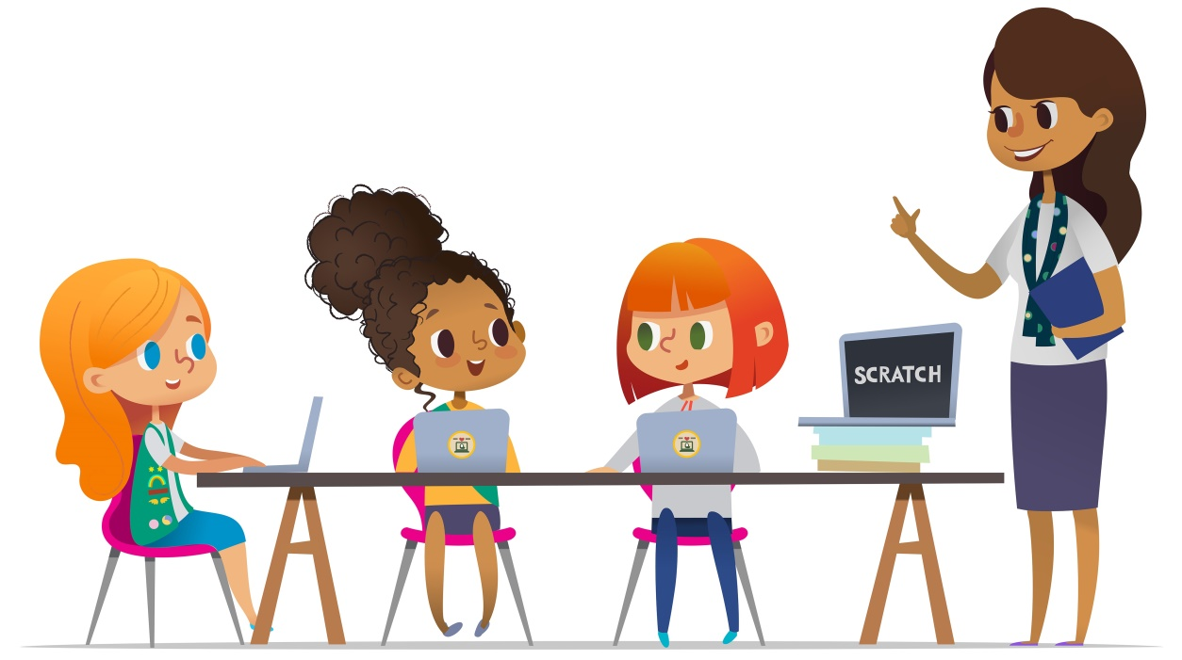
Questions: Contact us at info@girlcoders.net

Inspire
Girls to Explore
Computer Science

